History of EUV

(Lithography main techniques, Edited by Stefan Landis) = 1

THE VIEWPOINT by Banqiu Wu & Ajay Kumar Extreme Ultraviolet Lithography: Towards the Next Generation of Integrated Circuits = 2

ASML Webpage, the only provider of EUV equipment = 3

[www.hindsinstruments.com](http://www.hindsinstruments.com) = 4

EUV (Extreme Ultraviolet Lithography) is a branch of Lithography which was first invented around 1796 by a Bavarian playwright Alois Senefelder in Germany who found he could duplicate the scripts he wrote by writing on them in greasy crayon on limestone and then printing them in ink. This concept developed overtime from the reproduction of texts to the reproduction of pictures. A major challenge to this method was the issue of faithfully reproducing halftones (the process of using many dots of different shapes and sizes to produce a gradient like effect to create images. This issue was solved in 1884 by Meisenbach who invented the linear screen which was used to smoothen the granular nature of photosensitive emulsions (liquids that don’t mix, coming from the Latin word “To milk” with milk being an emulsion of fat and water) and so produce a clearer, more high quality image. The images these screens produce are actually optical illusions. Due to improvements in this technique, it is impossible for the human eye to see the dots used by the printing screens to produce the image.

= 1

Lithography has survived the test of time, going beyond its old domains of printed texts and macro imagery (close up, detailed images) and into the 20th century where in 1958 American Jack Kilby invented the very first printed circuit which is one of the main sources of the production of the electronic chips we see in all out personal computers, tablets etc in the world of today. With Moore’s law at the heart of this success pushing chip producers to double the density of the chips they produce with the process of Lithography being used to great effect in this area, with Optical lithography being the most used production choice currently. This process involves depositing a polymer layer of photosensitive resist onto a wafer and then exposed to wavelengths of a light source. This resist is then removed from the wafer at the conclusion of the process. This process is repeated several times in a cycle as you can see from the below image.

= 1

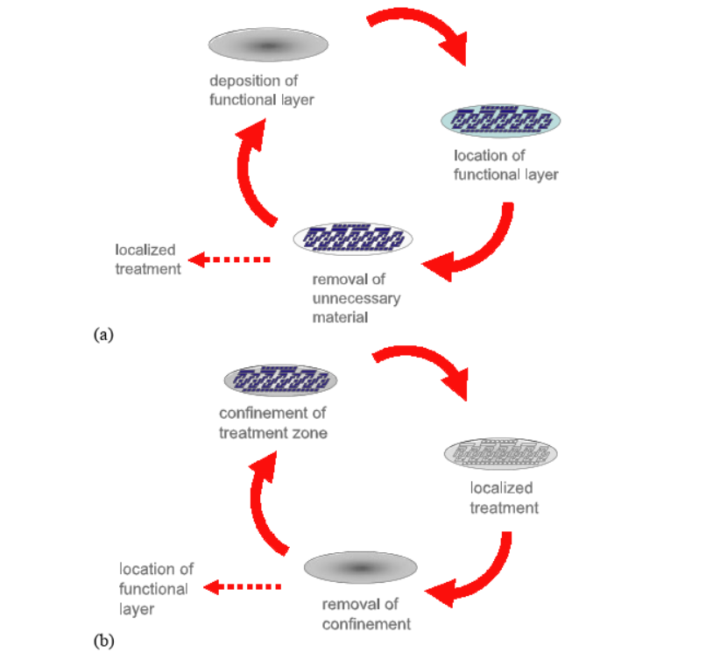

A process of lithography in chip production by either removing non-functional material (Subtractive, A) or by forcing local treatment of the wafer where needed (Additive, B).

(Lithography main techniques, edited by Stefan Landis, page xix, Figure 1.1)

Major Improvements were made to decrease the exposure wavelength all the way back in the 1980’s where tools started using different forms of radiation from a mercury lamp from 436nm to 405nm and then to 365nm. However, the first real transition came in the 1990’s with the switch from mercury lamps to deep ultraviolet lasers starting with 248nm with a Krf laser (Krypton fluoride laser) and 193 with an Arf laser (Argon fluoride laser). There was great investment into the reduction of this wavelength by many big named companies such as Sony and Intel. The next big attempt was to reduce the size down to 157nm with F2 lasers. However the projection optics material’s deformation (or bi-refringence) had been an major issue in this development in other words the light was being disrupted as it passed through the optic and ended up changing its stage leading to a poor quality image (=4) and so ending up being a major failure. Seemingly disproving Moore’s law, ending the efficiency streak and costing the industry millions. = 1

Which brings us to the modern era and onto EUV (Extreme Ultraviolet Lithography). EUV (or EUVL) was first proposed back in the 1980’s as the next bold step in chip manufacturing, one which would change the lights wavelength of the currently established 248nm and 193nm all the way down to 13.5nm wavelength (being almost as small as x-rays = 3) . These reductions would save so much space on chips and allow for much more transistors to be fitted onto chips allowing for them to be faster, smaller yet cheaper (due to the reduction in materials required) with them nowadays being 22nm, 14nm or 10nm in size(= 3). Even more impressively, the development of this technology could kickstart Moore’s law again which was long since considered invalid. = 1

It has seen very intensive development worldwide, being developed strongly from 1997 in the United States and then through European and Japanese development programmes with prototypes emerging in 2006 by the company ASML located in the Netherlands. However despite the effort, progress and success that has been had with EUV over the last 10 to 20 years, the technologies of today are holding back progress including issues such as a powerful enough power source required to run the EUV scanner in an efficient and cost worthy manner as well as the inability of industry facilities to produce flawless mask’s to use for printing. The research into these issues has costed several billions worth of US Dollars. As can be seen from the below table EUV is very much a new process with many more variables to account for compared to the current 193nm and 248nm optical lithography used by current KrF and ArF lasers of today.

= 1

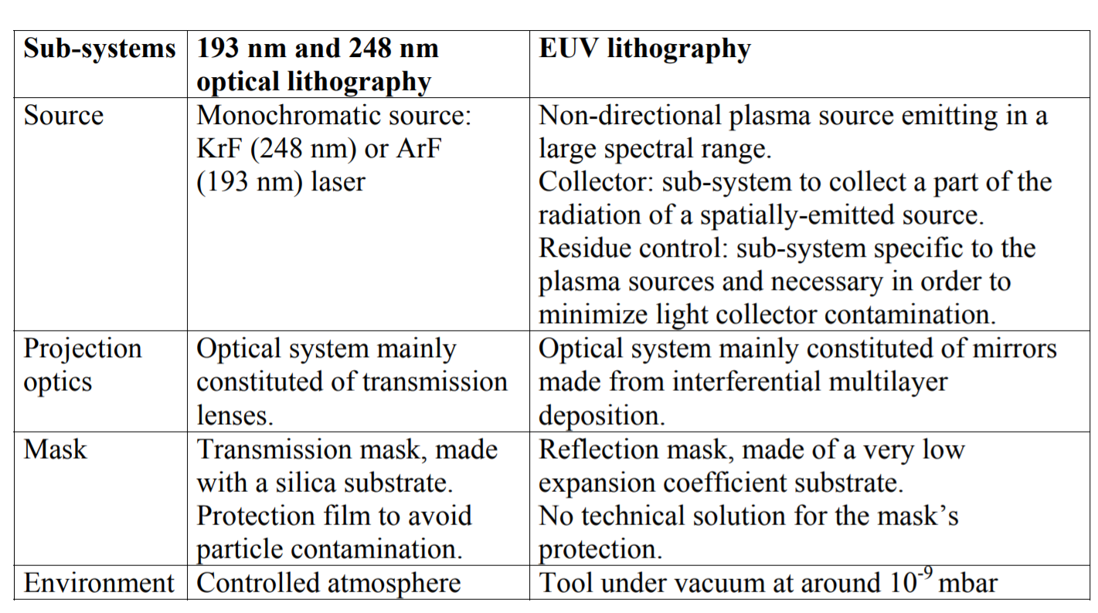

(Lithography main techniques, edited by Stefan Landis, page 43, table 2.1)

The Complexity of Lithography and specifically EUV has led to a significant cost increase from $50 million currently likely increasing to $100 million with the scanners and environments needed for EUV. However additional research is being undergone to move away from the current optical lithography to help reduce the costs of these devices such as the e beam created back in 1952 by DR. H.C. Karl-Heinz Steigerwald which has major advantages such as not requiring a mask, eliminating one of the current technical issues with EUV and also not being limited by wavelength or depth of field. However, there are disadvantages to this technology, the main one being that it can only print sequentially (pixel after pixel) which completely ruins any form of efficient productivity. However, it is still being considered of using many independently controlled beams (up to the tens of thousands), leading to a major increase in productivity.

(= 1).